NAME:AKSHARA JYOTHI.V
H.T.NO:2303A51793
BATCH NO:12
ASSIGNMENT-7.5
Task 1 (Mutable Default Argument – Function Bug)
Task: Analyze given code where a mutable default argument causes
unexpected behavior. Use AI to fix it.
# Bug: Mutable default argument
def add_item(item, items=[]):
items.append(item)
return items
print(add_item(1))
print(add_item(2))
Expected Output: Corrected function avoids shared list bug.
PROMPT USED:# Corrected function avoids shared list bug.
FIXED CODE:
def add_item(item, items=None):
if items is None:
items = []
items.append(item)
return items
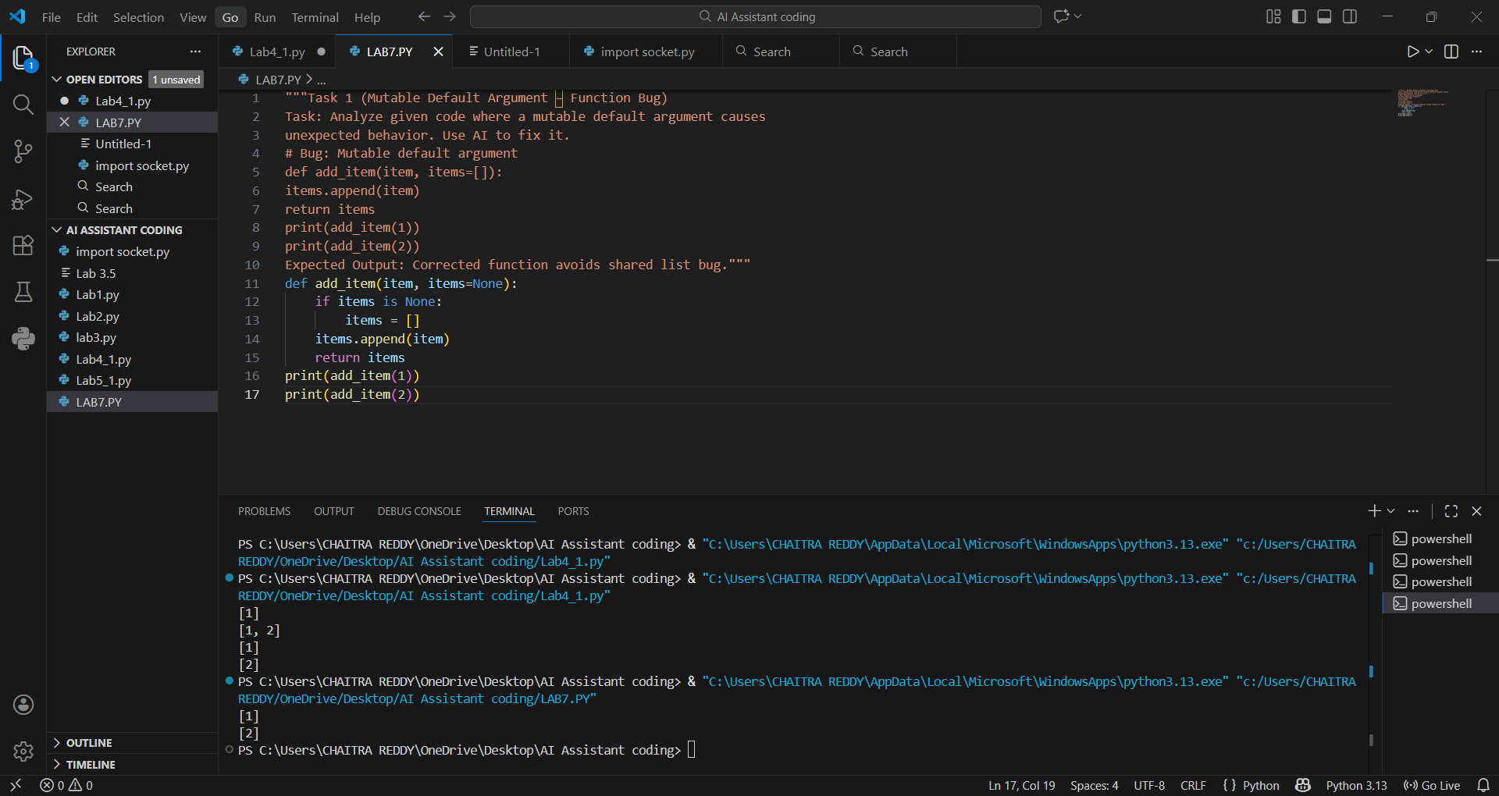
Observation:
In Python, default arguments are evaluated only once at function definition time.
Here, the list items=[] is shared across multiple function calls, so values from previous calls remain in the list, causing unexpected behavior.

Task 2 (Floating-Point Precision Error)
Task: Analyze given code where floating-point comparison fails.
Use AI to correct with tolerance.
# Bug: Floating point precision issue
def check_sum():
return (0.1 + 0.2) == 0.3
print(check_sum())
Expected Output: Corrected function
PROMPT USED: #Correct the floating-point comparison using tolerance in this Python code.

FIXED CODE:
import math
def check_sum(tolerance=1e-9):
return math.isclose(0.1 + 0.2, 0.3, abs_tol=tolerance)
print(check_sum())
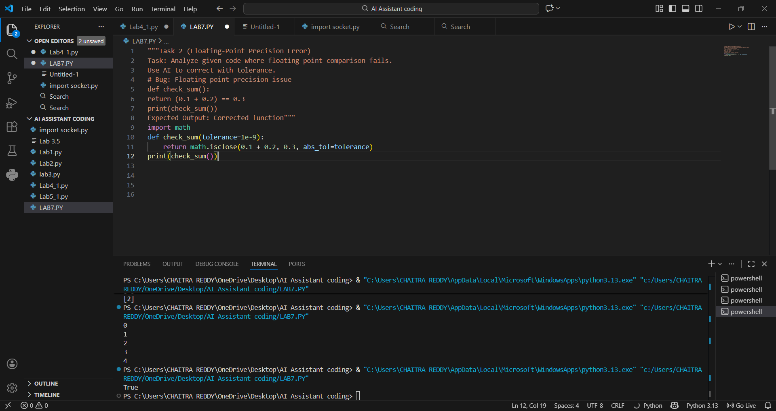

Observation:
In Python, default arguments are evaluated only once at function definition time.
Here, the list items=[] is shared across multiple function calls, so values from previous calls remain in the list, causing unexpected behavior.
Task 3 (Recursion Error – Missing Base Case)
Task: Analyze given code where recursion runs infinitely due to
missing base case. Use AI to fix.
# Bug: No base case
def countdown(n):
print(n)
return countdown(n-1)
countdown(5)
Expected Output : Correct recursion with stopping condition.
PROMPT USED: #Add a proper base case to fix infinite recursion in this function.
FIXED CODE:
def countdown(n):
if n <= 0:
print("Countdown finished!")
return
print(n)
return countdown(n-1)
countdown(5)
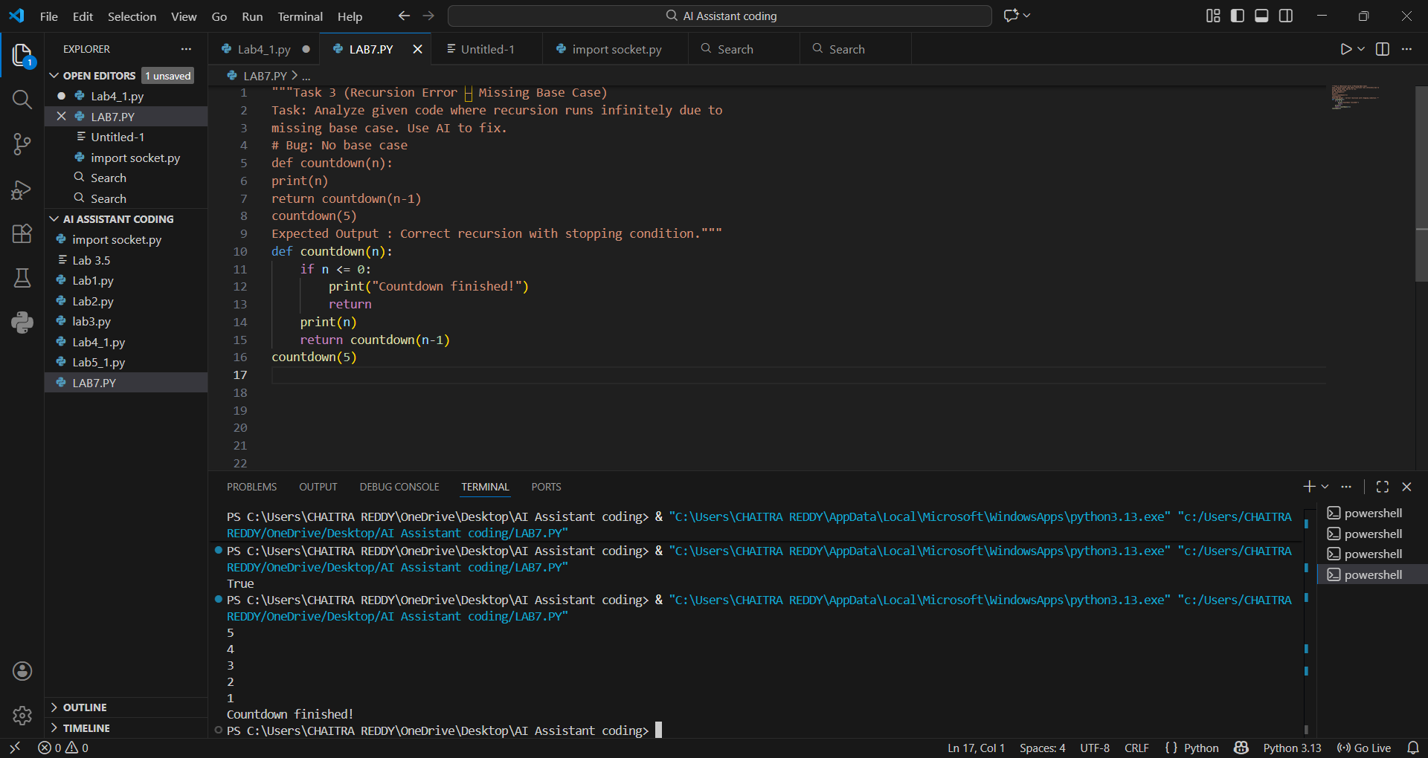

Observation:
The recursive function continuously calls itself without any stopping condition.
This results in infinite recursion and eventually causes a stack overflow error.

Task 4 (Dictionary Key Error)
Task: Analyze given code where a missing dictionary key causes
error. Use AI to fix it.
# Bug: Accessing non-existing key
def get_value():
data = {"a": 1, "b": 2}
return data["c"]
print(get_value())
Expected Output: Corrected with .get() or error handling.
PROMPT USED: #Fix the KeyError caused by accessing a missing dictionary key.
FIXED CODE:
def get_value():
data = {"a": 1, "b": 2}
return data.get("c", "Key not found")
print(get_value())
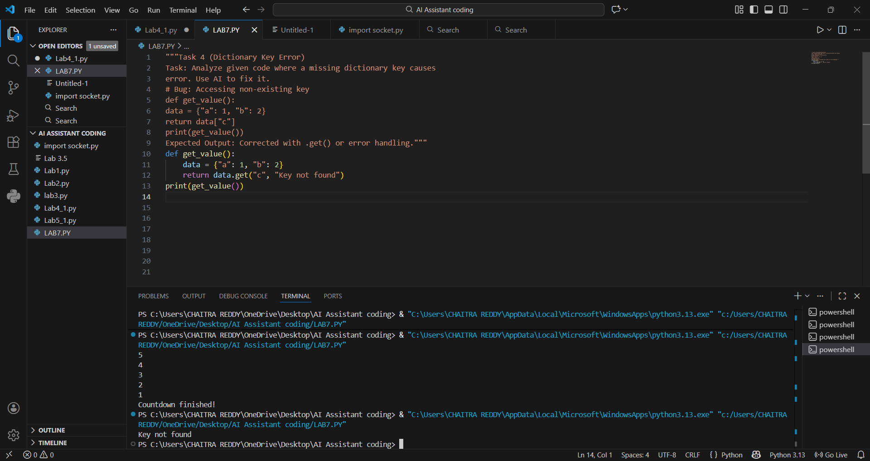

Observation:
The program tries to access a dictionary key ("c") that does not exist.
This raises a KeyError and causes the program to crash.
Task 5 (Infinite Loop – Wrong Condition)
Task: Analyze given code where loop never ends. Use AI to detect
and fix it.
# Bug: Infinite loop
def loop_example():
i = 0
while i < 5:
print(i)
Expected Output: Corrected loop increments i.
PROMPT USED:# Detect and fix the infinite loop in this Python code
FIXED CODE:
def loop_example():
i = 0
while i < 5:
print(i)
i += 1 # Fix: Increment i to avoid infinite loop
loop_example()

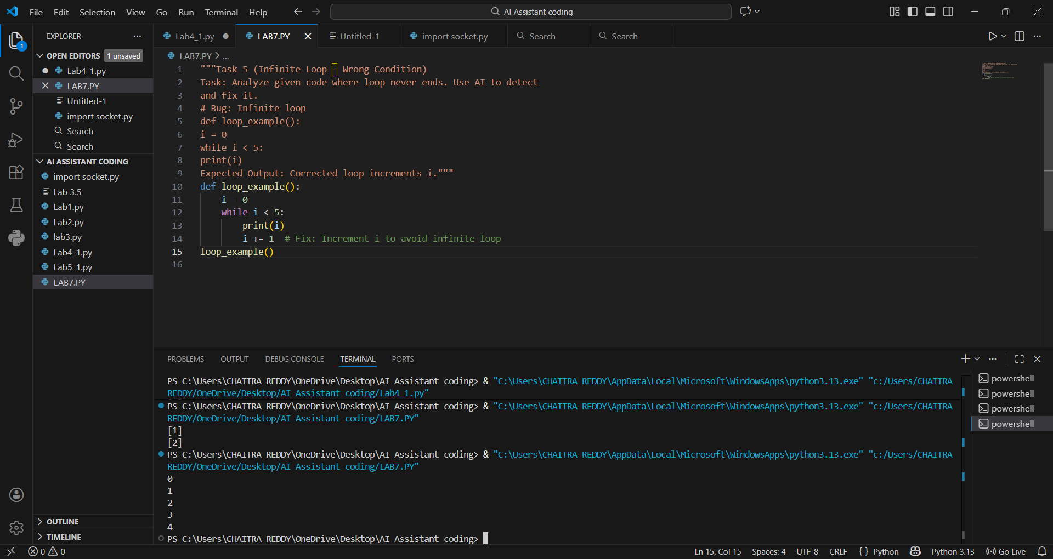

Observation:
The loop condition depends on variable i, but i is never updated inside the loop.
As a result, the condition remains true forever, creating an infinite loop.
Task 6 (Unpacking Error – Wrong Variables)
Task: Analyze given code where tuple unpacking fails. Use AI to
fix it.
# Bug: Wrong unpacking
a, b = (1, 2, 3)
Expected Output: Correct unpacking or using _ for extra values.
PROMPT USED:# Correct the tuple unpacking error in this statement.
FIXED CODE:
a, b, _ = (1, 2, 3)
print(a)
print(b)

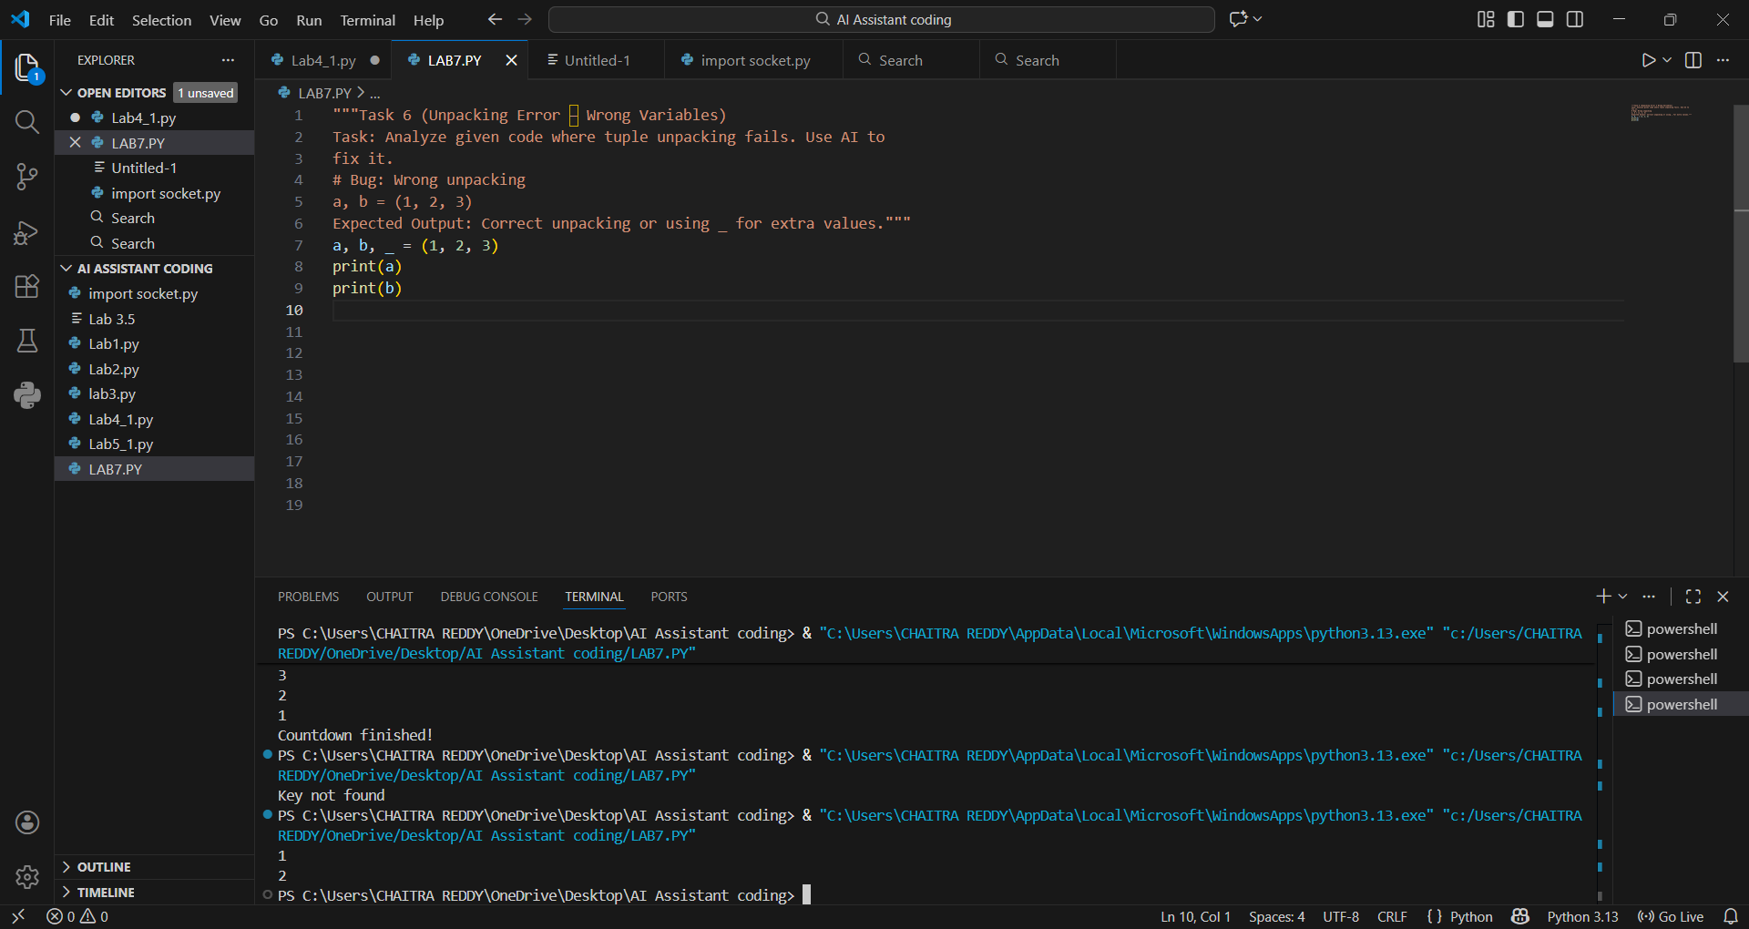

Observation:
The tuple contains three values, but only two variables are provided for unpacking.
This mismatch causes a ValueError during execution.Task 7 (Mixed Indentation – Tabs vs Spaces)
Task7: Analyze given code where mixed indentation breaks
execution. Use AI to fix it.
# Bug: Mixed indentation
def func():
x = 5
y = 10
return x+y
Expected Output : Consistent indentation applied.
PROMPT USED:# Fix the Python code by applying consistent indentation.
FIXED CODE:
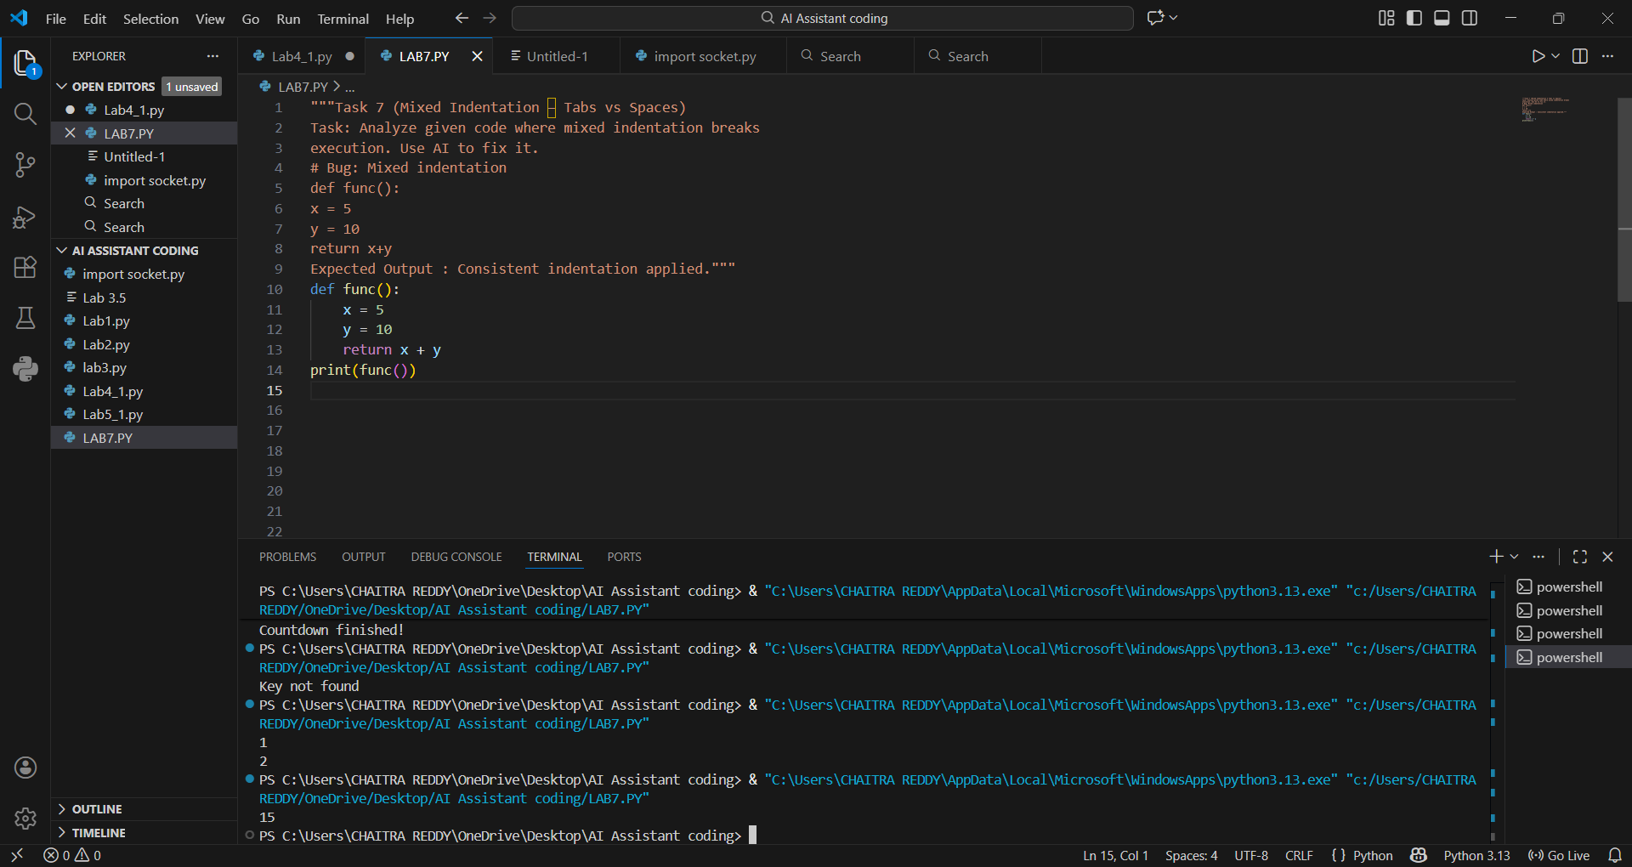

Observation:
Python uses indentation to define code blocks.
Mixing tabs and spaces or using inconsistent indentation leads to IndentationError or incorrect execution.
Task 8 (Import Error – Wrong Module Usage)
Task: Analyze given code with incorrect import. Use AI to fix.
# Bug: Wrong import
import maths
print(maths.sqrt(16))
Expected Output: Corrected to import math
PROMPT USED:# Correct the incorrect Python module import in this code.
FIXED CODE:
import math
print(math.sqrt(16))
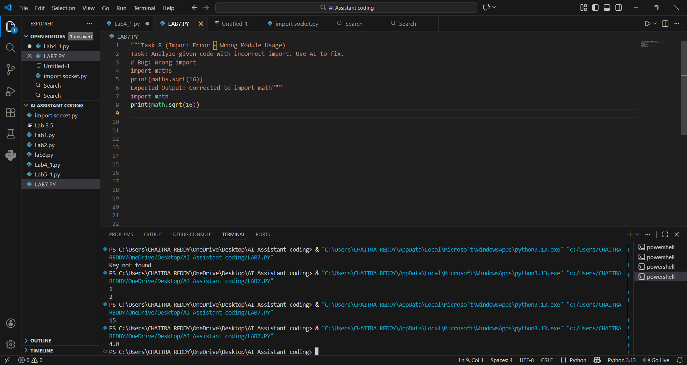

Observation:
The module maths does not exist in Python’s standard library.
Attempting to import it causes a ModuleNotFoundError.

